Given an integer n, return *a list of all possible****full binary trees****with* n *nodes*. Each node of each tree in the answer must have Node.val == 0.

Each element of the answer is the root node of one possible tree. You may return the final list of trees in **any order**.

A **full binary tree** is a binary tree where each node has exactly 0 or 2 children.

**Example 1:**

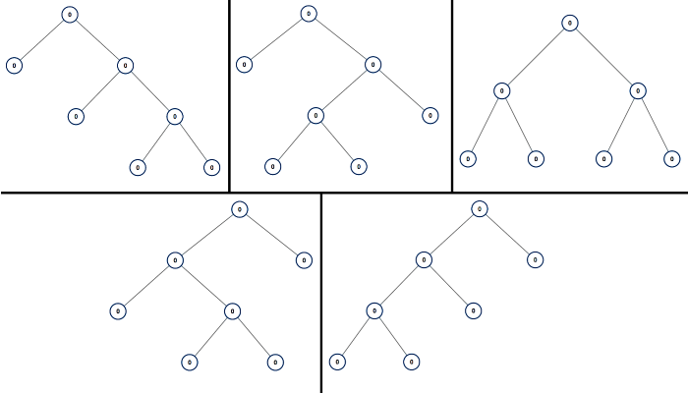

**Input:** n = 7

**Output:** [[0,0,0,null,null,0,0,null,null,0,0],[0,0,0,null,null,0,0,0,0],[0,0,0,0,0,0,0],[0,0,0,0,0,null,null,null,null,0,0],[0,0,0,0,0,null,null,0,0]]

**Example 2:**

**Input:** n = 3

**Output:** [[0,0,0]]

**Constraints:**

* 1 <= n <= 20